1.Write a Python Program to Solve a 8-Puzzle Problem ?

AIM:
To write a Python program to solve the 8-Puzzle problem using the A* Search Algorithm and find the shortest path from the initial state to the goal state.

ALGORITHM:
- Define the initial state and the goal state of the 8-puzzle.
- Use the A* search algorithm to solve the puzzle.
- Calculate the heuristic value (number of misplaced tiles) for each state.
- Find the position of the blank tile (0).
- Generate all possible next states by moving the blank tile (up, down, left, or right).
- Add the generated states to a priority queue based on their total cost:
  - f(n) = g(n) + h(n)
  - g(n) = cost from the start state.
  - h(n) = heuristic value (misplaced tiles).
- Repeat the process until the goal state is reached.
- Display the sequence of moves from the initial state to the goal state.
- Stop the program when the goal state is found or report that no solution exists.

CODE:
import heapq
# Goal State
goal = [
[1, 2, 3],
[4, 5, 6],
[7, 8, 0]
]
# Find position of blank (0)
def find_blank(state):
for i in range(3):
for j in range(3):
if state[i][j] == 0:
return i, j
# Heuristic: Number of misplaced tiles
def heuristic(state):
count = 0
for i in range(3):
for j in range(3):
if state[i][j] != 0 and state[i][j] != goal[i][j]:
count += 1
return count
# Convert list to tuple for hashing
def to_tuple(state):
return tuple(tuple(row) for row in state)
# Generate possible moves
def get_neighbors(state):
neighbors = []
x, y = find_blank(state)
moves = [(-1,0), (1,0), (0,-1), (0,1)]
for dx, dy in moves:
nx, ny = x + dx, y + dy
if 0 <= nx < 3 and 0 <= ny < 3:
new_state = [row[:] for row in state]
new_state[x][y], new_state[nx][ny] = new_state[nx][ny], new_state[x][y]
neighbors.append(new_state)

return neighbors
# A* Search
def a_star(start):
pq = []
heapq.heappush(pq, (heuristic(start), 0, start, []))
visited = set()
while pq:
f, g, state, path = heapq.heappop(pq)
if state == goal:
return path + [state]
state_tuple = to_tuple(state)
if state_tuple in visited:
continue
visited.add(state_tuple)
for neighbor in get_neighbors(state):
if to_tuple(neighbor) not in visited:
heapq.heappush(
pq,
(g + 1 + heuristic(neighbor),
g + 1,
neighbor,
path + [state])
)
return None
# Driver Code
start = [
[1, 2, 3],
[4, 0, 6],
[7, 5, 8]
]
solution = a_star(start)
if solution:
print("Solution found!\n")
for step in solution:
for row in step:
print(row)
print()
else:
print("No solution exists.")

OUTPUT:
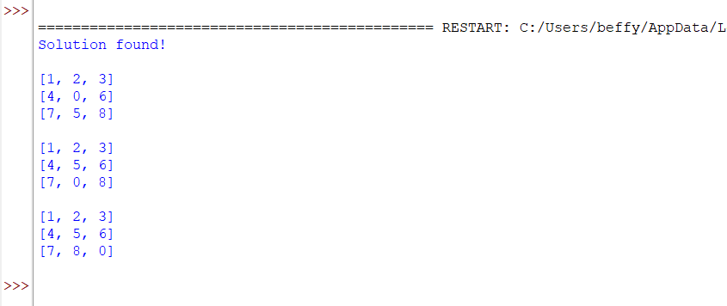

RESULT:
The 8-Puzzle problem was successfully solved using the A* Search Algorithm, and the sequence of moves from the initial state to the goal state was displayed.

2.Write a Python Program to Solve 8-Queen Problem ?

AIM:
To write a Python program to solve the 8-Queen Problem using the Backtracking Algorithm, such that no two queens attack each other.

ALGORITHM:
- Start with an empty 8 × 8 chessboard.
- Place a queen in the first column.
- Check whether the queen is safe by ensuring:
- No other queen is in the same row.
- No other queen is in the upper-left diagonal.
- No other queen is in the lower-left diagonal.
- If the position is safe, place the queen.
- Move to the next column and repeat the process.
- If no safe position is found in a column, backtrack by removing the previously placed queen.
- Continue until all 8 queens are placed successfully.
- Display the final arrangement of the queens on the chessboard.

CODE:
N = 8
# Check if a queen can be placed safely
def is_safe(board, row, col):
# Check left side of current row
for i in range(col):
if board[row][i] == 1:
return False
# Check upper-left diagonal
i, j = row, col
while i >= 0 and j >= 0:
if board[i][j] == 1:
return False
i -= 1
j -= 1
# Check lower-left diagonal
i, j = row, col
while i < N and j >= 0:
if board[i][j] == 1:
return False
i += 1
j -= 1
return True
# Solve using backtracking
def solve(board, col):
if col >= N:
return True
for row in range(N):
if is_safe(board, row, col):
board[row][col] = 1
if solve(board, col + 1):
return True
board[row][col] = 0
return False
# Print solution
def print_solution(board):
print("Solution:")
for row in board:
print(row)
board = [[0] * N for _ in range(N)]
if solve(board, 0):
print_solution(board)
else:
print("No solution exists")

OUTPUT:
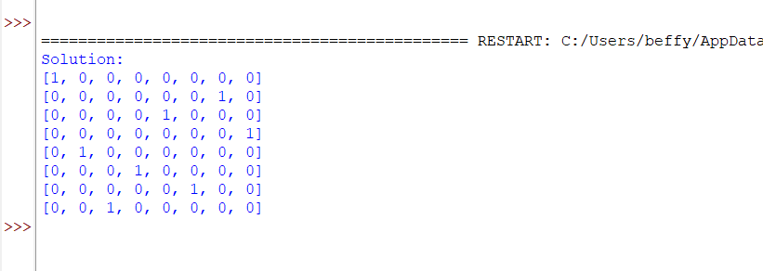

RESULT:
The 8-Queen Problem was successfully solved using the Backtracking Algorithm, and a valid arrangement of 8 queens on the chessboard was obtained such that no two queens attack each other.

3.Write a Python Program for Water Jug Problem ?

AIM:
To write a Python program to solve the Water Jug Problem and obtain the target quantity of water using two jugs.
ALGORITHM:
- Initialize Jug 1 and Jug 2 as empty.
- Fill Jug 1 completely.
- Transfer water from Jug 1 to Jug 2 until Jug 2 is full.
- Empty Jug 2.
- Transfer the remaining water from Jug 1 to Jug 2.
- Fill Jug 1 again.
- Transfer water from Jug 1 to Jug 2 until Jug 2 becomes full.
- Stop when the target quantity (2 litres) is obtained in Jug 1.
- Display "Target Achieved".
CODE:
# Water Jug Problem
# Jug 1 Capacity = 4 Litres
# Jug 2 Capacity = 3 Litres
# Target = 2 Litres
jug1 = 0
jug2 = 0
# Fill Jug1
jug1 = 4
print("Fill Jug1 :", jug1, jug2)
# Transfer Jug1 -> Jug2
transfer = min(jug1, 3 - jug2)
jug1 -= transfer
jug2 += transfer
print("Transfer :", jug1, jug2)
# Empty Jug2
jug2 = 0
print("Empty Jug2 :", jug1, jug2)
# Transfer Jug1 -> Jug2
transfer = min(jug1, 3 - jug2)
jug1 -= transfer
jug2 += transfer
print("Transfer :", jug1, jug2)
# Fill Jug1
jug1 = 4
print("Fill Jug1 :", jug1, jug2)
# Transfer Jug1 -> Jug2
transfer = min(jug1, 3 - jug2)
jug1 -= transfer
jug2 += transfer
print("Transfer :", jug1, jug2)
print("\nTarget Achieved!")

OUTPUT:
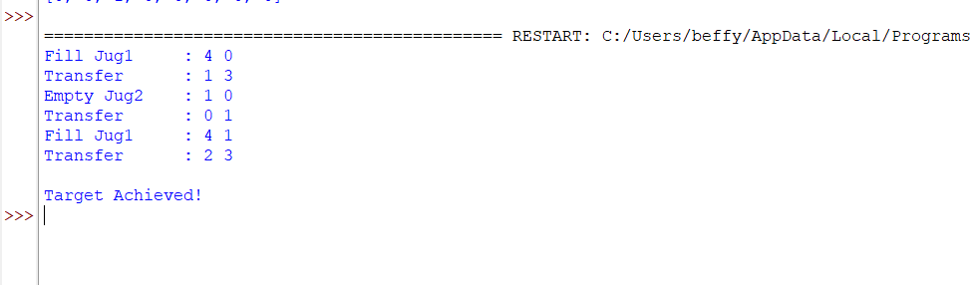

RESULT:
Thus, the Python program to solve the Water Jug Problem was successfully executed, and the target quantity of 2 litres was obtained.
4. Write a Python Program for Cript-Arithmetic Problem?

AIM:
To write a Python program to solve a Crypt-Arithmetic Problem by assigning unique digits to letters such that the arithmetic equation is satisfied.

ALGORITHM:
- Read the words involved in the crypt-arithmetic equation.
- Identify all unique letters.
- Generate all possible digit assignments for the letters.
- Ensure that no leading letter is assigned the digit 0.
- Replace each letter with its assigned digit.
- Check whether the arithmetic equation is satisfied.
- If a valid assignment is found, display the solution.
- Stop the program after finding the correct solution.

CODE:
from itertools import permutations
letters = ('S', 'E', 'N', 'D', 'M', 'O', 'R', 'Y')
for p in permutations(range(10), len(letters)):
d = dict(zip(letters, p))
if d['S'] == 0 or d['M'] == 0:
continue
send = 1000*d['S'] + 100*d['E'] + 10*d['N'] + d['D']
more = 1000*d['M'] + 100*d['O'] + 10*d['R'] + d['E']
money = 10000*d['M'] + 1000*d['O'] + 100*d['N'] + 10*d['E'] + d['Y']
if send + more == money:
print("SEND =", send)
print("MORE =", more)
print("MONEY =", money)
break

OUTPUT:
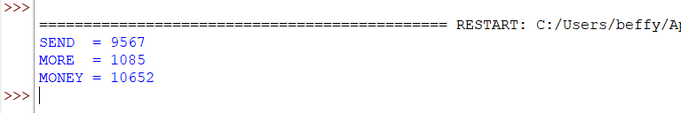

RESULT:
Thus, the Python program to solve the Crypt-Arithmetic Problem was successfully implemented and executed

5. Write a Python Program for Missionaries Cannibel Problem?

AIM:
To write a Python program to solve the Missionaries and Cannibals Problem using the Breadth-First Search (BFS) algorithm.

ALGORITHM:
- Represent the state as (Missionaries Left, Cannibals Left, Boat Side).
- Start with all missionaries and cannibals on the left bank.
- Generate all valid boat moves.
- Ensure that on either bank, missionaries are never outnumbered by cannibals (unless there are no missionaries).
- Use BFS to explore all possible valid states.
- Stop when all missionaries and cannibals reach the right bank.
- Display the sequence of states.

CODE:
from collections import deque
def is_valid(m_left, c_left):
m_right = 3 - m_left
c_right = 3 - c_left
if m_left < 0 or c_left < 0 or m_left > 3 or c_left > 3:
return False
if m_left > 0 and m_left < c_left:
return False
if m_right > 0 and m_right < c_right:
return False
return True
def bfs():
start = (3, 3, 'L')
goal = (0, 0, 'R')
queue = deque([(start, [start])])
visited = set()
moves = [(2,0), (0,2), (1,1), (1,0), (0,1)]
while queue:
state, path = queue.popleft()
if state == goal:
print("Solution Path:")
for step in path:
print(step)
return
if state in visited:
continue
visited.add(state)
m, c, boat = state
for dm, dc in moves:
if boat == 'L':
new_state = (m-dm, c-dc, 'R')
else:
new_state = (m+dm, c+dc, 'L')
if is_valid(new_state[0], new_state[1]):
queue.append((new_state, path + [new_state]))
bfs()

OUTPUT:

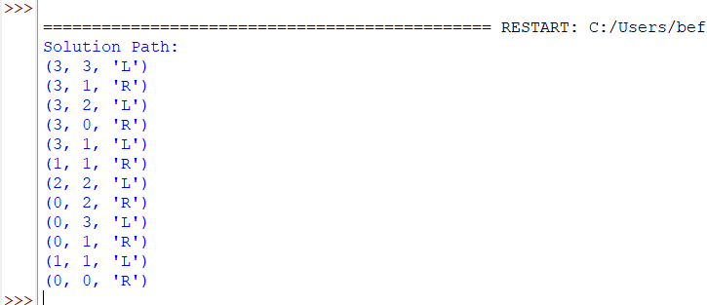

RESULT:
Thus, the Python program to solve the Missionaries and Cannibals Problem using the Breadth-First Search (BFS) algorithm was successfully implemented and executed.

